Amazon AWS
Steps to create a IAM user
1.Go IAM
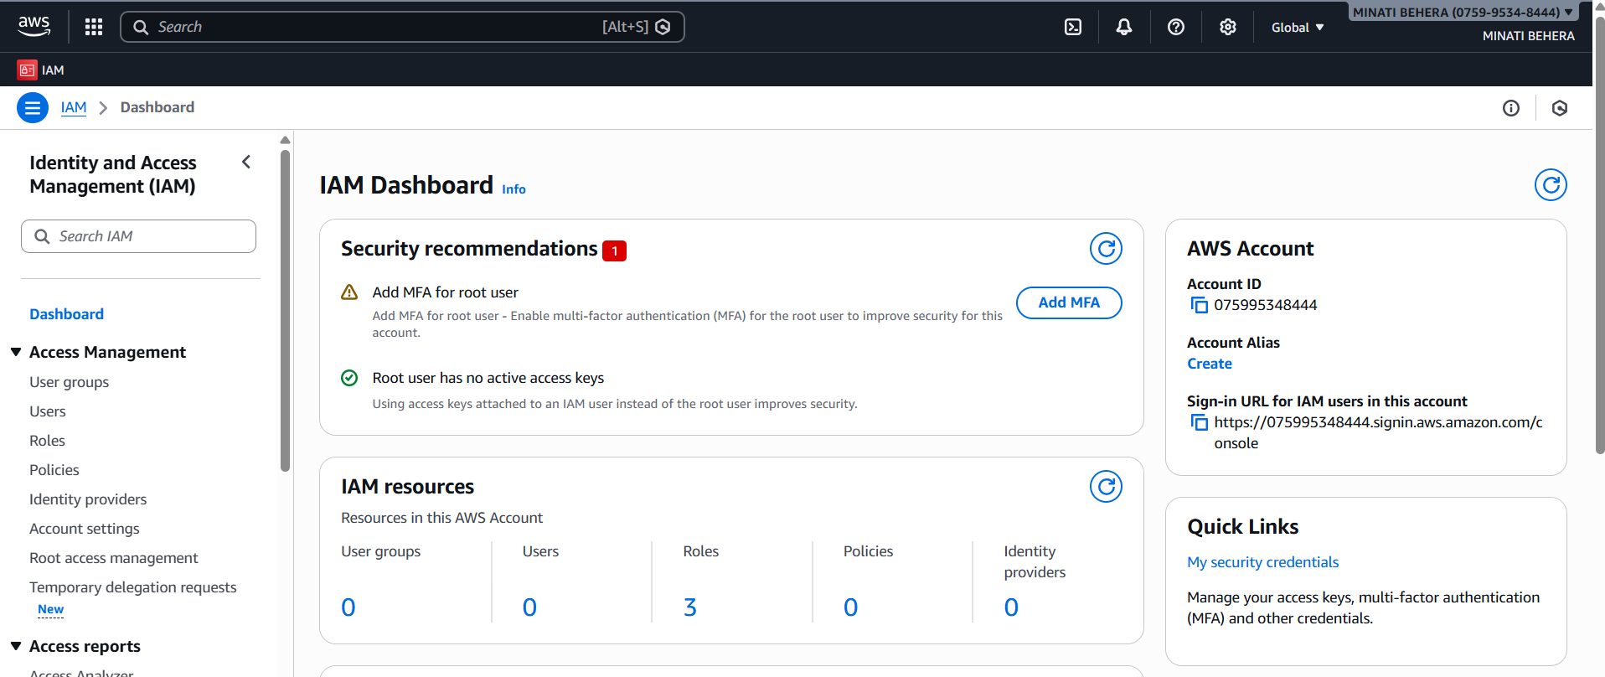

Here no service available
2.Go to user section
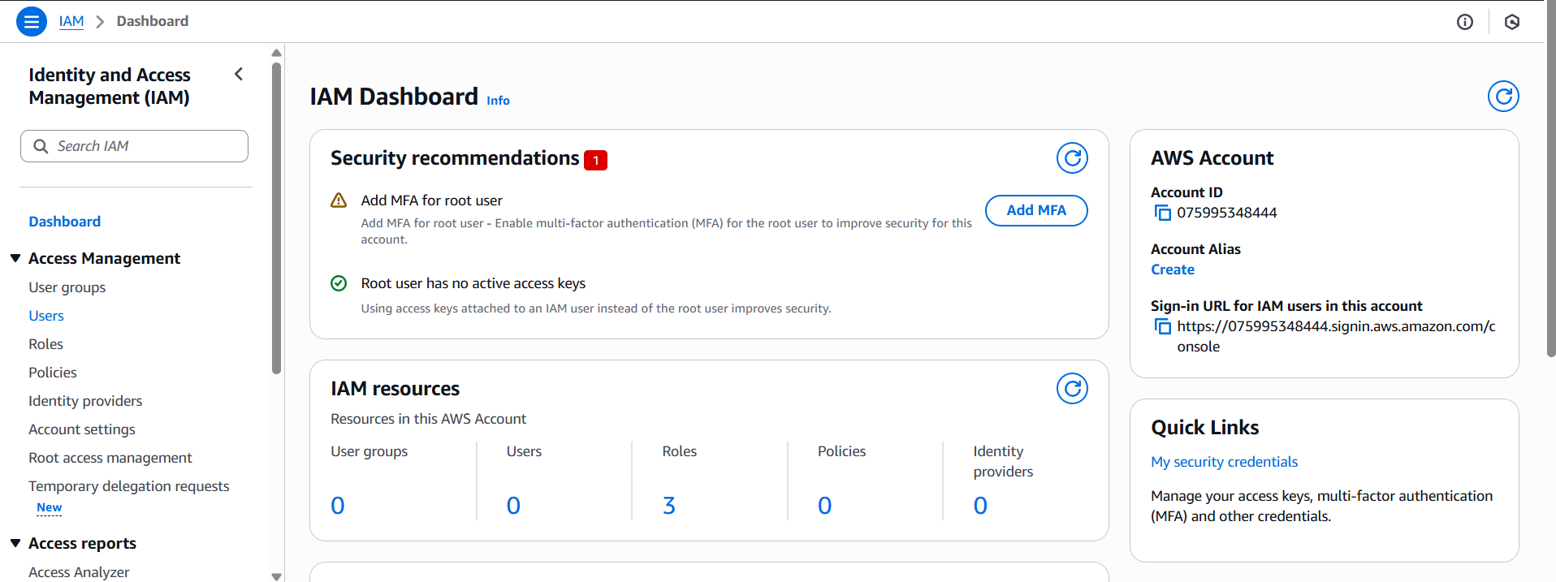

3.Go to Create user

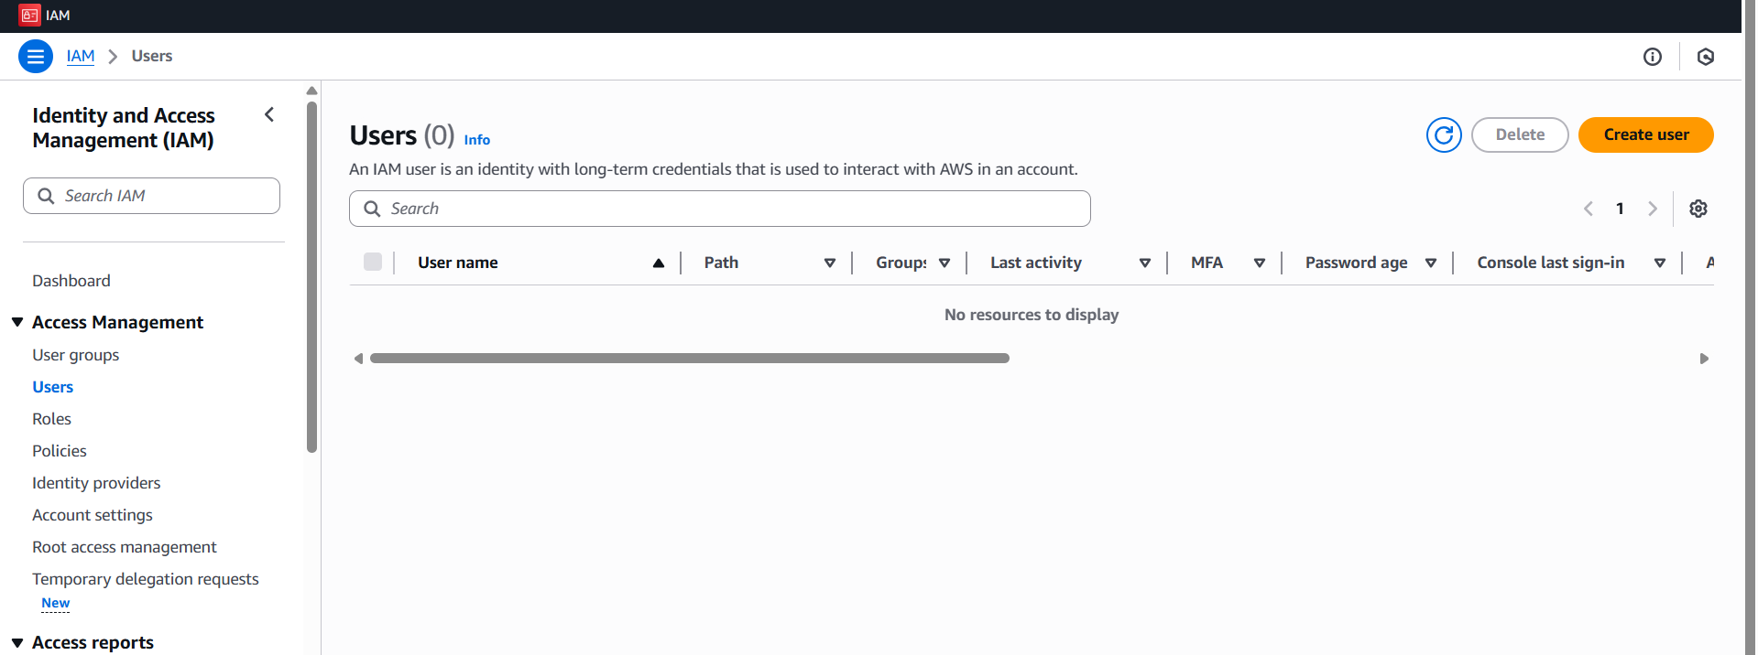
4.Set user name &set password
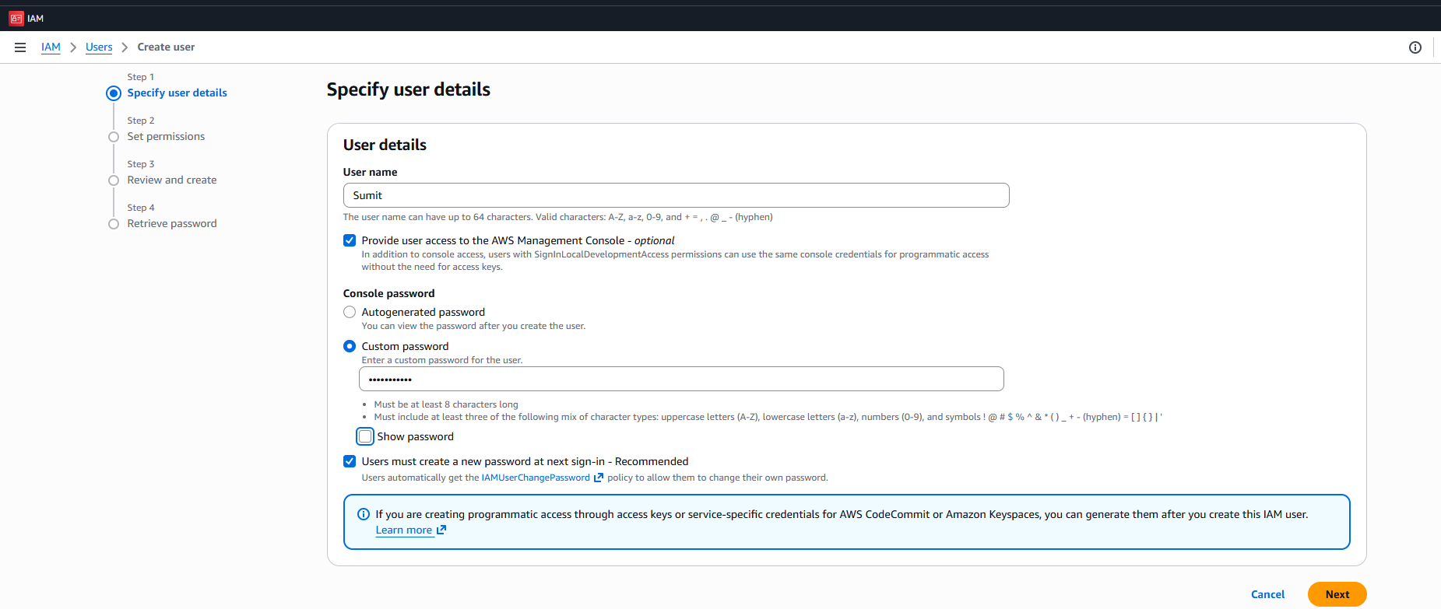
5.provide any policies as required
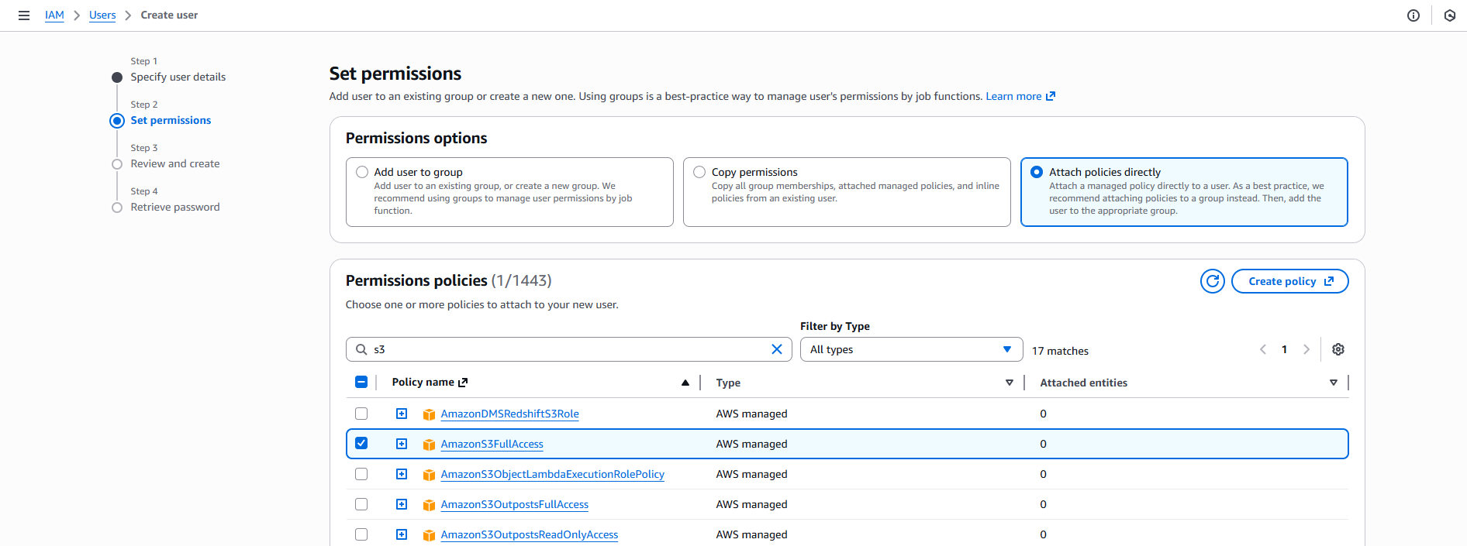

6.Review all things
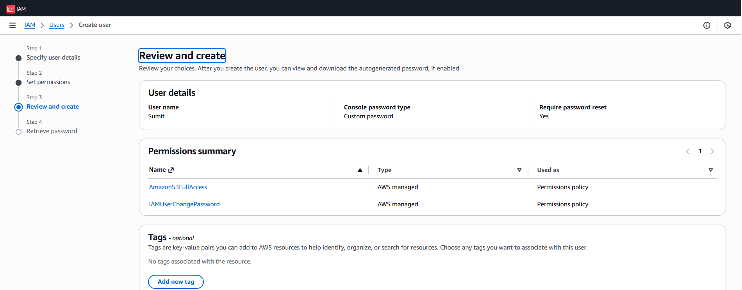
7.User created Sucessfully
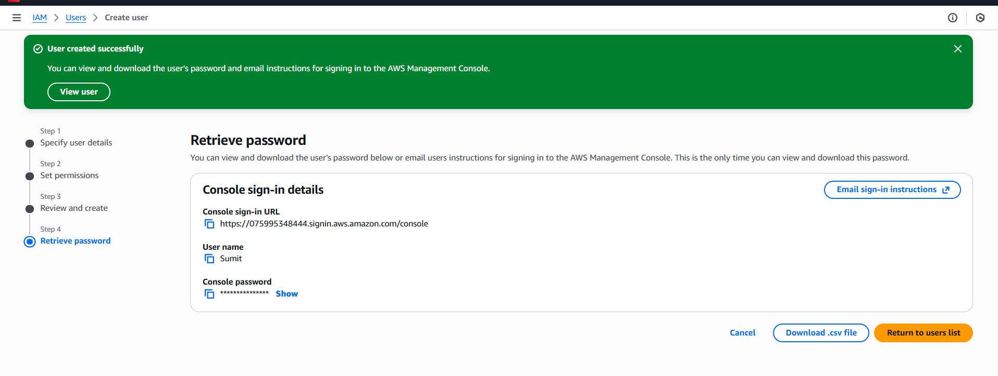
8.Download the Csv file for further reference

9.copy the sign-url & open in a new tab
10.Login in a new tab as new user created
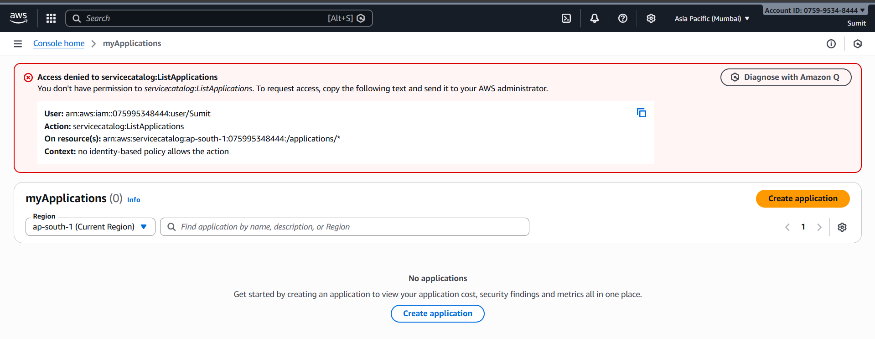
11.Again login as root
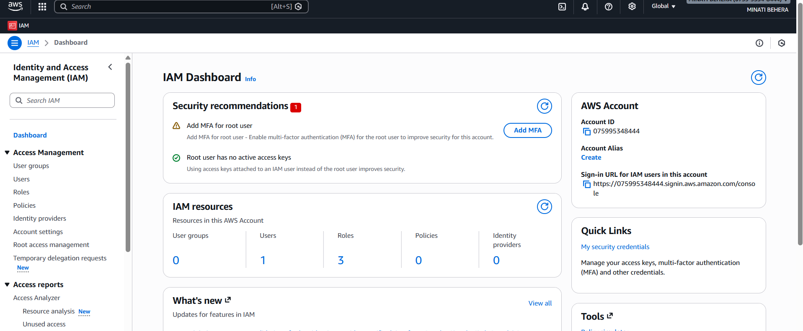

12.One user is created
